Introduction to Economics
Instituitoional Affiliatrion
Course
Date

Problem Set Questions
- According to a recent survey, one out of ten investors have cryptocurrencies in their portfolios. Consider a sample of 15 investors.

marks
Total 6 marks

- The marks from a statistics exam are normally distributed with a mean of 72 and a standard deviation of 15.


marks
Total 9 marks

- An insurance firm is budgeting the premium rates for the year 2022. The firm decided the rates of the year 2021 based on the average amount they paid as insurance claims, which was £1,000. However, the manager believes that the actual amount of claims that they pay is higher and therefore the firm should increase the insurance premium. The manager took a sample of 16 claims and found a sample mean claim of £1,350 with a sample standard deviation of £400. Conduct a hypothesis test to assist the manager in taking her decision. Use the 1% significance level. Comment on your findings. Should the firm decrease or increase the insurance premium?
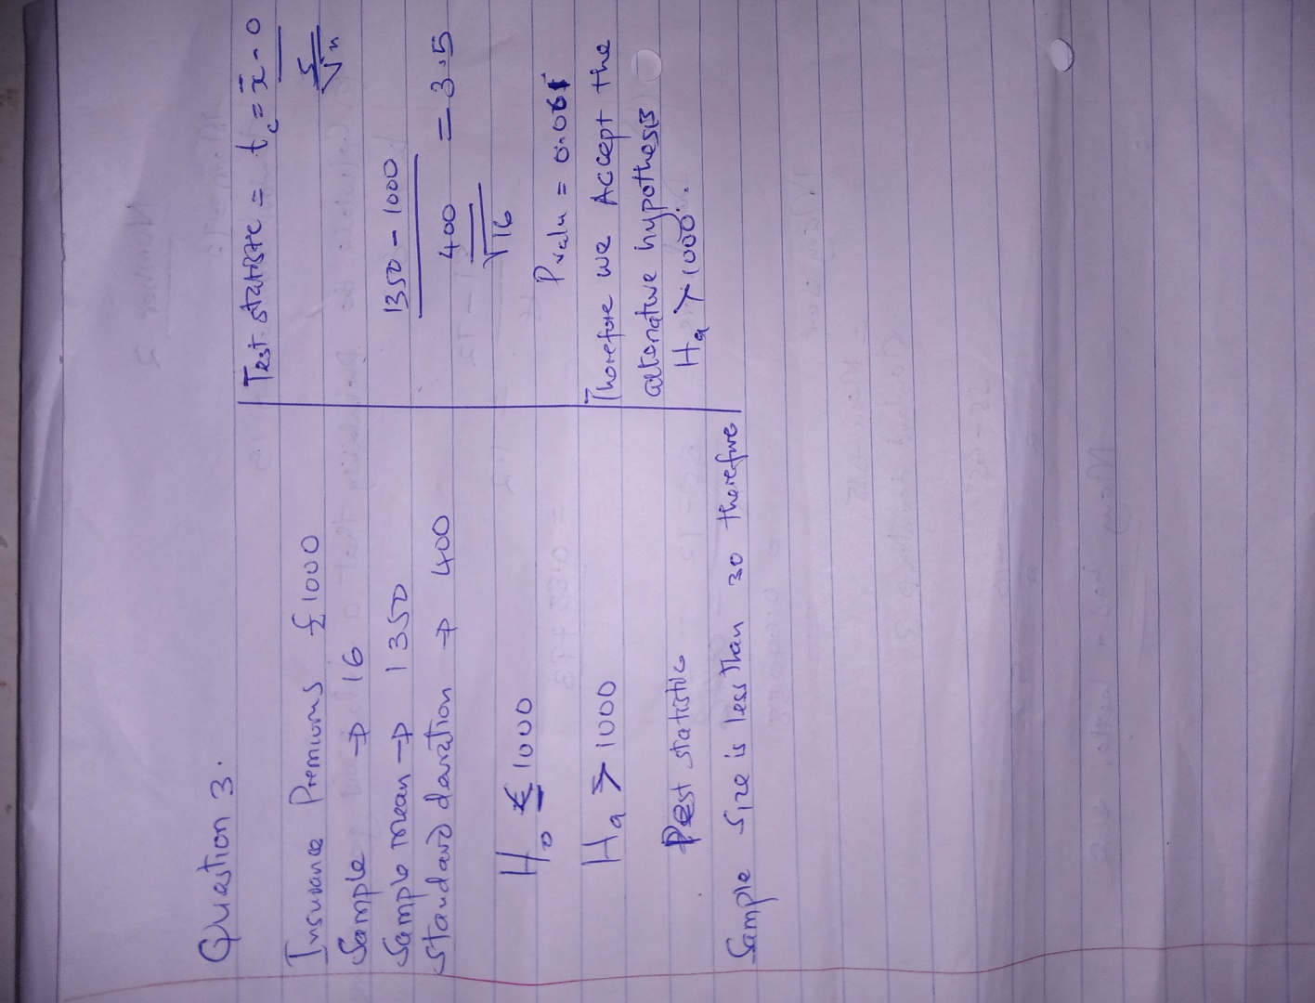

marks

- When oil prices increase, drivers are more concerned with their car’s fuel consumption. For the last five years a driver has kept a record of the petrol mileage of the car and found a variance of 5.4 miles per litre (MPL). The driver would like to know whether the variability of MPL has recently changed. She collected the petrol mileage from her last eight fill-ups which are listed in the table below. Conduct a hypothesis test to infer whether the variability has changed. Use the 5% level of significance. What is your conclusion?

Miles per litre (MPL)
6.2 | 5.1 | 6.5 | 5.5 | 7.2 | 8.0 | 6.5 | 4.8
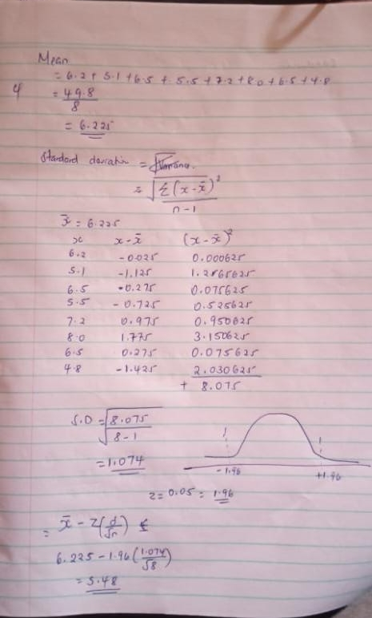

marks

- About 70% of the population of children own smart phones. This has led to discussions about the age limit for owning smart phones. In a UK survey of 550 participants in the age group 25-50 years old, 300 agreed that smart phones can be given to children. In addition, from 500 participants in the age group 51-70 years old, 250 responded that smart phones can be given to children. Conduct a hypothesis test to determine whether there is a difference between the two age groups about people who agree that smart phones can be given to children. Use the 1% significance level. What is your conclusion? Next, find the p-value of the statistic. Does your conclusion change?


8 marks

- A firm’s accounting department analyses the variability of weekly unit costs reported from its two factories, A and B. A sample of 16 cost reports from factory A and 23 cost reports from factory B were collected. The analysis shows unit cost standard deviations equal to 6.2 for factory A and 5.7 for factory B. Conduct a hypothesis test to determine whether the two factories differ in terms of unit cost variability. Use the 5% level of significance. What is your conclusion?


- The European Heart Association conducted a study with 25 individuals to investigate what affects the risk of strokes. The econometric model of the study was:
strokei = a1 + a2agei + a3bpi + a4 ln cigsi + εi
where stroke is the risk of strokes, age is age in years, bp is blood pressure measured in millimetres of mercury (mmHg), and ln cigs is the natural logarithm of the number of cigarettes smoked. The OLS results are given below.

OLS, dependent variable: stroke
 | Coefficient | Standard Error
constant | −65.15 | 15.20
age | 1.25 | 0.65
bp | 0.30 | 0.06
lncigs | 8.55 | 2.20

Mean dependent var | 26.95 | S.D. dependent var | 14.85
Sum squared resid | 530.21 | S.E. of regression | 5.75
Adjusted R-squared | 0.70 | R-squared | 0.80
Log-likelihood | −61.15 | Akaike criterion | 130.30
Schwarz criterion | 134.29 | Hannan-Quinn | 131.08

  - Is the variable age statistically significant? Is the variable lncigs statistically significant? Write the null and alternative hypotheses. Use the 1% significance level. Comment on your findings.

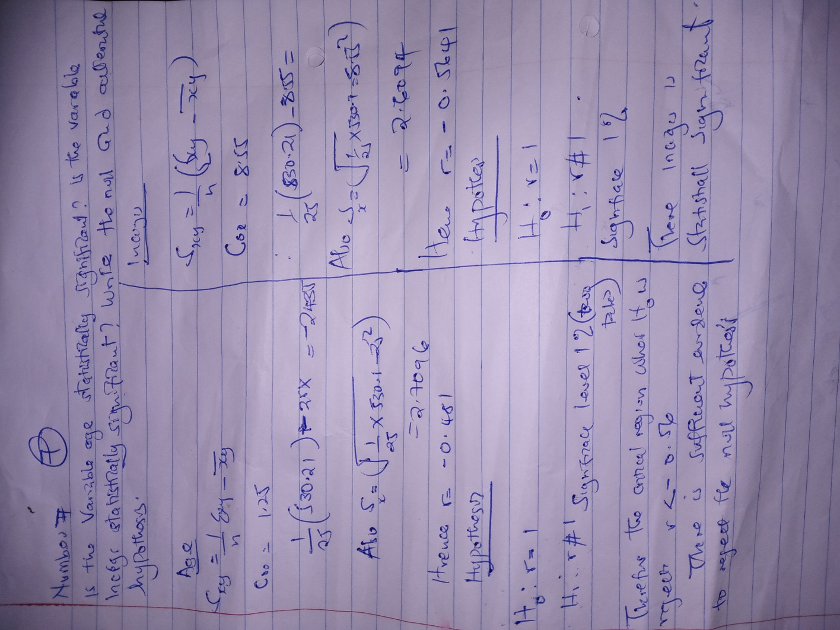

  - What happens to the risk of stroke if the number of cigarettes smoked increases by 2%?
An increase in the number of cigarette smokers will rise the risk of stroke.

8 marks

3 marks

  - Test the overall significance of the multiple regression. Write the null and the alternative hypotheses. Use the 5% significance level. Comment on your finding.

  - Interpret R².

6 marks

3 marks
Total 20 marks

- An investment is supposed to be a hedge against inflation if its price and/or rate of return keeps pace with inflation. To examine this hypothesis you estimated an OLS regression between the price of gold ( gold ), the New York stock exchange index
( NYSE ), and the inflation rate ( inflation ), using annual data for the USA for the period 1990-2020. The results are presented below.

OLS, using observations 1990-2020
Dependent variable: gold
 | Coefficient | Standard Error
constant | 47.971 | 65.141
NYSE | −0.064 | 0.015
inflation | 3.726 | 0.797

Mean dependent var | 336.15 | S.D. dependent var | 103.384
Sum squared resid | 180015 | S.E. of regression | 80.181
Adjusted R-squared | 0.398 | R-squared | 0.438
F | 10.900 | P-value(F) | 0.003
Log-likelihood | −178.322 | Akaike criterion | 362.645
Schwarz criterion | 366.947 | Hannan-Quinn | 364.047
rho | 0.507 | Durbin-Watson | 0.975
Test for normality of residual
Test statistic χ 2 = 18.157, p-value = 0.044
(2)
Chow test at observation 2001
Test statistic F = 3.479

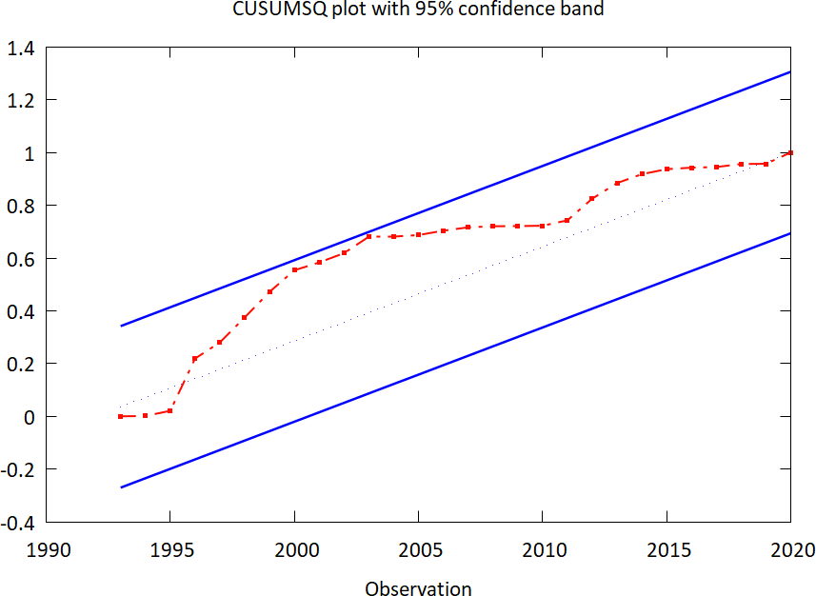

OLS, using observations 1990-2020
Dependent variable: uhat
 | Coefficient | Standard Error | t-ratio | p-value
constant | 95.483 | 79.189 | 1.206 | 0.240
NYSE | 0.013 | 0.015 | 0.879 | 0.388
inflation | −0.983 | 0.896 | −1.097 | 0.284
uhat(t−1) | 0.633 | 0.207 | 3.046 | 0.005
uhat(t−2) | −0.337 | 0.239 | −1.408 | 0.173
uhat(t−3) | 0.068 | 0.208 | 0.330 | 0.744

Mean dependent var | 7.055 | S.D. dependent var | 77.921
Sum squared resid | 106416 | S.E. of regression | 69.549
Adjusted R-squared | 0.203 | R-squared | 0.350
F | 2.378 | P-value(F) | 0.072
Log-likelihood | −155.131 | Akaike criterion | 322.262
Schwarz criterion | 330.255 | Hannan-Quinn | 324.705
rho | −0.073 | Durbin-Watson | 0.055

  - Is there evidence of a structural break in 2001? Use the 5% significance level.

6 marks
  - Are the parameters of the model stable? Use the 5% significance level.

4 marks

  - Are the residuals normally distributed at the 5% significance level?

  - According to the Durbin-Watson test statistic, is there evidence of autocorrelation? Use the 5% significance level.

  - Estimate the Breusch-Godfrey test statistic. Is there evidence of autocorrelation? Use the 5% significance level.

5 marks

8 marks

8 marks

  - Is US inflation statistically greater from the 2% target of the US Fed (central bank)? Use the 1% significance level.

4 marks
Total 35 marks

End of Problem Set Questions

